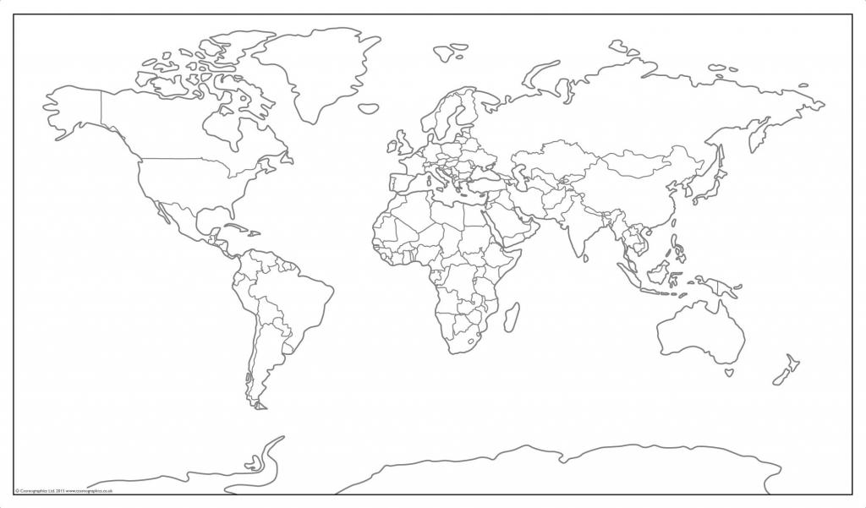

Cosmographics 2015

|  |  |  |  |
| --- | --- | --- | --- |
|  | | | |
|  |  |  |  |
|  |  |  |  |
|  |  |  |  |
|  |  |  |  |

**Activity 1: Mapping**

The acronym **BOLTSS** is used in mapping, this helps us to never forget the 6 important features that each map must contain. What does **BOLTSS** stand for? List each term and give a brief description of each.

|  |  |
| --- | --- |
| **B** |  |
|  |
|  |  |
| **O** |  |
|  |
|  |  |
| **L** |  |
|  |
|  |  |
| **T** |  |
|  |
|  |  |
| **S** |  |
|  |
|  |  |
| **S** |  |
|  |
|  |  |

**

*Quick check!*

Does your map on the have all the BOLTSS features?

Put in or complete any missing BOLTSS features.

**Activity 2: Continents and Oceans**

Using a world map in an atlas complete the following:

* Label all 7 continents and colour each differently for your legend
* Label all 5 oceans
* Complete all mapping tasks in pencil and neatly

**Activity 3: Location, Location**

Find the following locations on the map and label them using their allocated number not the location’s name. You will not have enough room to put the location’s name on the map.

|  |  |  |  |
| --- | --- | --- | --- |
| **1** | Canberra | **16** | Kiev |
| **2** | Moscow | **17** | Helsinki |
| **3** | Tokyo | **18** | Georgetown |
| **4** | Wellington | **19** | Ottawa |
| **5** | Athens | **20** | Taipei |
| **6** | Cape Town | **21** | Jakarta |
| **7** | Beijing | **22** | Kampala |
| **8** | Washington D.C. | **23** | Damascus |
| **9** | Santiago | **25** | Astana |
| **10** | Copenhagen | **25** | Paris |
| **11** | Lima | **26** | Madrid |
| **12** | Funafuti | **27** | Harare |
| **13** | Seoul | **28** | New Delhi |
| **14** | Columbo | **29** | Kuala Lumpur |
| **15** | Kabul | **30** | London |

**Activity 4: Latitude and Longitude**

1. Pick 15 of the locations from the table above and write them into the table below

2. Use an atlas to find the coordinates (latitude and longitude) of each location



|  |  |
| --- | --- |
| Location | Coordinates |
|  |  |
|  |  |
|  |  |
|  |  |
|  |  |
|  |  |
|  |  |
|  |  |
|  |  |
|  |  |